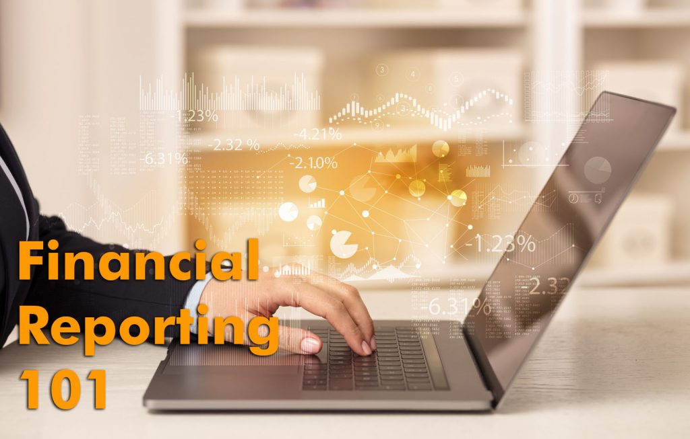

Financial Reporting 101
Running an organization without proper financial reporting, or without understanding how to interpret financial reports, can put the organization at risk. What financial reports should you have and what questions do you need to ask? This depends in large part on your organization’s financial situation, however today we will focus on two of the most commonly used reports and suggest some key questions that these reports can help you to answer.

Reconcile to the Bank
Before generating any financial reports, it is important to know that your books have been reconciled to the bank to the end of the period being reported. What this means is that all deposits and payments on your bank statement match all deposits and payments recorded in your accounting system. This can be ascertained with a Bank Reconciliation report.
Once you are confident your books are reconciled to the bank, financial statements can be generated from the accounting system. The most commonly used reports are the balance sheet (also called the Statement of Financial Position) and the income statement (also called the P&L or Statement of Operations).

Balance Sheet
The balance sheet provides a snapshot of your assets (what your own), liabilities (what you owe) and net assets (the difference between the two) at a point in time. Some key questions to ask about the balance sheet include:
- How much cash do we have on hand? How (and why) has that changed compared to the previous period?
- What percentage of accounts receivable is current? Which specific accounts are past-due? Has provision been made for uncollectible accounts?
- Who do we owe money to, and are payments being made on time?
- What makes up balances in Prepaid Expenses, Accrued Liabilities and Deferred Revenue?
Several key balance sheet ratios should be calculated and monitored, and these are described in more detail in our blog Three Key Financial Ratios NPO Board Members Should Monitor.

Income Statement
The income statement measures revenues and expenses that have been recorded over a specific period, for example the year ending December 31, 20XX. Key questions to ask include:
- How do revenues and expenses compare to prior periods, for example compared to the same period last year? If the change is material, what is the explanation?
- How do amounts compare to budget? If variances are material, what is the reason?
- What is our forecasted net income? What might prevent us from achieving that forecast?
Interpreting financial statements and knowing what questions to ask is a key responsibility of management and the board of directors. An excellent resource for non-financial people is CPA Canada’s A Guide to Financial Statements of Not-For-Profit Organizations.
Richard MacNeill, FCPA, FCMA, CMC, Dipl. T. is a partner at OTUS Group, a team of advisors to business, government and not-for-profit organizations.

Three Key Financial Ratios NPO Board Members Should Monitor

Financial ratios use data from your financial statements to provide indicators of financial performance, helping you to understand financial results and flagging trends or patterns. They can serve as useful early warning indicators of potentially serious financial problems, and should therefore be monitored on a regular basis.
When reviewing financial statements of our not-for-profit clients, there are three key financial ratios we often bring to management’s attention:
1. Current Ratio: Do I have enough money to pay bills as they come due?
This is the ratio of current assets to current liabilities. It is a measure of the organization’s ability to meet its short-term commitments. A ratio of less than 1:1 indicates the organization may have difficulty paying its bills in a timely manner, and may be facing cash flow issues.
2. Deferred Revenue Ratio: Am I spending money that was received up front and intended to pay for goods or services that have not yet been delivered?
It is the ratio of cash and investments to deferred revenue (also called unearned revenue). The amount of cash on hand should exceed the deferred revenue balance. If there is not at least as much cash as deferred revenue, then the organization has used funds that it has not yet actually earned. It has in effect borrowed from expected future revenues.
3. Operating Reserve Ratio: How long can I sustain operations without additional funding?
The ratio of expendable net assets to total expenses. It measures whether there are enough resources (operating reserves) to meet expenditures without having to borrow from lenders. Not for profits should have expendable net assets of at least 25% of annual expenditures.
Financial ratios are a valuable tool for any organization, providing insight into the financial health of an organization, and raising flags to signal when management action may be required. Different not-for-profits will have a need for different ratios, so we recommend discussing with your financial advisor which ones may be the most useful to report and monitor for your organization.
Find out more about financial ratios – call me and we can have a conversation. We can also talk about improving operating efficiency, reducing costs and strengthening your organization. Reach me at 613-727-1230 ext. 212 or rmacneill@otusgroup.com
Richard MacNeill, FCPA, FCMA, CMC, Dipl. T. is a partner at OTUS Group, a team of advisors to business, government and not-for-profit organizations.

It’s Time to Stop Using Paper Cheques

Cheque usage poses a serious risk to businesses. While many have eliminated paper cheques, others still use this out-dated payment method and are likely unaware of the risks:
An employee of Teva Canada, a Toronto-based pharmaceutical company, fraudulently requisitioned 63 cheques totaling $5.4 million, payable to two fictitious entities and four Teva customers.
The employee had no authority to requisition cheques or approve payments. The cheques were processed and the funds deposited into bank accounts of the employee and his accomplices.
Teva sued the banks and argued that they should not have cashed the phony cheques, however the Courts ruled that the banks were not responsible for the loss.
This incident underscores why you should not pay suppliers with paper cheques: they can be lost, stolen, counterfeited, forged, altered and improperly endorsed.
Fortunately, all payments can now be made electronically – it is not necessary to use paper cheques and be exposed to substantial risk.
Cheques are also very costly. Scotiabank’s Cheque Cost Issuance Model shows that costs can be anywhere from $15-$25 per cheque. In some cases, it’s as high as $50 per cheque. And what if the cheque is lost or stolen? The company then may need to deal with a potential fraud issue and must pay to reissue the cheque.

Along with risk reduction, electronic payment methods offer many other benefits over cheques:
- Cheque printing, mailing and handling costs are eliminated
- Security and internal control is significantly strengthened, reducing chance of fraud and theft because EFT payment approvals utilize strong on-line banking security, instead of much weaker paper-based signature approvals. The EFT system should allow for a dual electronic signature requirement
- No need to store and secure blank cheques
- Clerical work and errors are reduced
- Ability to manage and forecast cash flow is improved. Payments can be set up with various due dates, and postdated for up to 35 days
- Stale-dated cheques are no longer a possibility
- Bank reconciliations are simplified, because there are no outstanding cheques to account for
- Payment approval process is streamlined. Payments are ready for approval immediately upon entry into the EFT system and can be approved from anywhere, anytime, by authorized signing authorities. Added benefit: when your signing authorities are out of the office, they can still approve payments easily from their smart phone!
- EFT is environmentally friendly. Paper & ink used in producing cheques and envelopes is eliminated, as is the carbon footprint resulting from the physical distribution of cheques

Richard MacNeill, FCPA, FCMA, CMC, Dipl. T. is a partner at OTUS Group, a team of advisors to business, government and not-for-profit organizations.

